



EU- SUPPORT TO DEMOCRATIC GOVERNANCE IN NIGERIA
CONPONENT 4A – SUPPORT TO MEDIA

Draft Report on Deepening Audience Research for Electoral Cycle Programming

Title: Deepening Audience Research for Electoral Cycle Programming

Kind of activity: (Meeting, Workshop, training, visit etc…give additional details about the activity here:

Training Workshop

Date(s): February 16 - 17, 2022

Venue(s): 77 Palms Hotel, Agodi GRA, Ibadan.

Participants: (List names and designation,and disaggregate whether male or female. Please provide the participant list as an annex.

Objectives of the activity: (Why was the activity carried out and should be linked to the result?)

The activity sought to strengthen the capacity of broadcast media practitioners in Audience Research for Electoral Cycle Programming.

Methodology: (Explain how the activity was conducted, i.e. through presentations, discussions, etc.)

Presentations/Discussions

Content: (Give a brief on agenda of the activity.)

Summary of Content of the Activity:

S/N | Presentations
1. | Project Over-view/Overall Objective
2. | Components of the electoral cycle and what the audience expect
3. | Audience Research Methods: Rationale and Overview
4. | Group Work
5 | Group presentations
6 | From audience research report to programmes: How to inculcate findings in programme structure and contents
7 | Questions and responses

INTRODUCTION/BACKGROUND:

In a bid to further strengthen the broadcast media to provide fair, accurate and ethical coverage of the electoral process in Nigeria, the Institute for Media and Society (IMS) organised a two-day capacity building for broadcast media practitioners, with the theme: Deepening Audience Research for Electoral Cycle Programming. The two-day activity was a follow up to earlier training engagements in audience research target at improving media capacity to understand their diverse audience, to enable them develop the appropriate contents, particularly towards the electoral cycle.

The activity brought together broadcast journalists from programmes/news and current affairs of Television and Radio stations across the southern states of Nigeria provided opportunity for practitioners to share their experiences and also acquired more skills in audience research.

As the use of audience research grows within the media industry, it becomes imperative to expand capacity building engagements which introduces new innovations into practice and enable further penetration and deepening of audience research across the industry.

Narrative:
- Describe key issues dealt with during the activity reported by theme (not necessarily in chronological order);
- Information on participation and interaction among attendees;
- Note that this is not meant to be a transcript, rather a summary of the main components of the activity;
- The narrative should be presented objectively.

Speaking at the opening of the two days capacity building with the theme: Deepening Audience Research for Electoral Cycle Programming, the Executive Director of IMS, Dr. Akin Akingbulu appreciated participants for making time to attend the event, while further noting that, practitioners need relevant skills to deliver their expected roles in the democratic governance process.

He made it clear that the media should not just assume that they know their audience and what the audience want or need. Dr. Akingbulu emphasised the need for the media to understand its audience, which according to him requires scientific methods.

Dr. Akingbulu noted that past capacity building activities in audience research have continued to produce tangible results, as the understanding of the concept of audience research is being deepened within the broadcast media industry and other relevant stakeholders. He observed that capacity of practitioners in audience research has continued to improve with the introduction of a resource materials which came out initial engagements organised by IMS in 2018.

In view of upcoming elections, more importantly the 2023 general elections, Dr. Akingbulu reiterated the need for media professionals and platforms to improve on contents towards educating and informing citizens, who solely rely on the information provided by the media to make informed decisions.

He urged participants to make good use of the opportunity provide by the training to develop the required capacity, and also use the skills and knowledge acquired to improve the delivery of quality programming targeted at the electoral cycle.
Highlights of the Two-Day Capacity Building:

The two-day capacity building was engaged through presentations from facilitators on different sub-themes in audience research.

Interactive sessions also provided opportunity for participants to share their experiences on what their understanding of audience research and how this could inform good programming, particularly for electoral cycle. Participant were of the view that with the new knowledge and skills acquired, they were set to change the face of electoral cycle programming in their individual platforms.
Components of the Electoral Cycle and What the Audience Expect:
In his presentation on components of the electoral cycle and what the audience expect, Professor Ayobami Ojebode maintained that good electoral cycle programming/content is very crucial to the building of a viable democracy in the country, and as such efforts should be made by media platforms to understand audience perception and preference, particularly as it relates to the electoral cycle programming, which provides citizens opportunity to be well educated on issues affecting them and their participation in governance.

He noted in as much as citizens rely so much on the media to get relevant information which would help them make informed decisions during different stages of the electoral process, it then became highly imperative for the media to give attention to audience perception and demands which can only be identified through a deliberate action of conducting audience research.

While giving a x-ray of corporate social responsibility of the media towards the society within which they operate, the communication don explained that media platforms should not forget to play their roles of setting agenda through the deployment of contents which promotes the interest of the public, particularly in performing the role of watchdog and a bridge between government and the governed, thereby making a good input towards achieving good governance.

He maintained that the trust reposed in the media by the public is so enormous, and as such, the media cannot afford to breach this trust else they will become mere tool of propaganda in their audience eye.

Speaking of what the audience expects of the media, Ojeode noted that the expectation of the audience is to have an unbiased media that will give them the right information, and a medium through which they could relate with the government. Give these clear expectations, the media holds it as a responsibility to work professionally in the delivery of their responsibilities.

Giving a summary of components of the electoral cycle, the facilitator explained that the electoral cycle is made up of long complex processes, begins with the pre-election process, elections, vote count, announcement and post-election, provision of legal framework for resolving election disputes through Election Tribunals, then Appeal Court.

Audience Research Methods: Rationale and Overview:

Dr. Babatunde Ojebuyi in his presentation defined media audience research is the use of social science and market research techniques to study the traits of actual and potential audiences.

Amongst other audience research methods available to the media includes:

- Survey
- Focus Group Discussion (FGD)
- In-depth interviews etc.

He observed that, a quality audience research data that will produce a good report can only be achieved if media platforms conducting audience consider and satisfy some factors/conditions which include:

- Defining the goals of the research in a clear manner, as research questions or hypotheses;
- Defining the target group or segment of the population to be researched comprehensively;
- Choosing the appropriate research design to answer the research questions or test the hypotheses;
- Developing a data collection instrument (e.g., questionnaire, interview guide, observation instructions) that produces valid and reliable data;

As a result of technological advancement, media audience research has adapted other methods which include: use of web-based platforms, podcasting, telephone downloads, and so on.
Audience Research is expected to do among other things:

- To Discover Audience Preferences, attitudes, knowledge, behaviour
- Provide information that will help media platforms adjust programme contents and structure accordingly to ensure social responsibility

Group Work and Presentations

Participants were divided into four groups to work on the development of a questionnaire prototype for audience research.

In their group work and presentations, participants developed audience research questionnaires following the guide provided and made presentations to show that the process was well understood.

Using Findings from Audience Research:

The findings of your audience research are to be used by your station to enhance programme structure and content, therefore, audience research reports should be written in simple, clear and intelligible language that the station personnel can read, understand and use for the primary purpose.

It is also expected that all issues raised in the findings should be carefully studied by media platforms and well analysed to enable platform manager make informed decisions on possible reviews that will be needed to address audience concerns.

Concerns Raised by Participants:

Participants were of the view that audience research is central to the success and effectiveness of electoral cycle programming, however, they pointed out a number of concerns which include the following:

1. Unavailability of funds to conduct audience research by media

2. Stations readiness to conduct audience research

3. Fair of application of results of audience research in programming given ownership influence
and possible regulatory sanctions

4. Challenge of not getting attention of respondents

5. Data analysis rigorous and intensive

6. The process requires adequate planning

7. Challenges of not getting a true feedback from respondents and so on

In addressing concerns raised by participants, it was made clear that professionalism is very key to media performance and as such capacity should be developed to do the needful without violating ethics. Participants were encouraged to develop capacity, so that responsibility and expectations will be achieved.

PART 2 – OUTPUT/OUTCOMES

Expected achievement of the activity: (Give a brief description of the outcome of the activity regardless of what it was meant to achieve. Note that the actual outcome could be different from the expected one, which should contribute to the production of evidence for milestones.)

- Broadcast media professionals had their capacity improved strengthened in audience research for electoral cycle programming

- Media platform now see the need to deepen audience research to ensure good programming

- Media platforms show capacity to deliver audience research and also step-down the training within their platforms.

- Electoral cycle programming will improve as media platform use knowledge acquired

- Resource material on audience research circulated

Contribution to results:
(This part produces the evidence and demonstrates how the activity contributed to the result planned for on the work-plan.)
The activity has further improved broadcast media capacity to deepen audience research for electoral cycle programming, thereby strengthening the media to provide fair, accurate and ethical coverage of the electoral process in Nigeria.

Challenges, lessons learned and recommendations: (Point out obstacles encountered during the activity (may be logistical) and challenges that came out during the development of the activity (i.e. concerning the effectiveness of the activity), lessons learnt and recommendations. Each challenge identified should have relevant recommendation(s).)

Challenges:

No challenge was identified.

Lessons Learned:

It is important to increase capacity building for broadcast media professionals

Recommendations:

Implications for the whole programme: (This is an important section. You should give as much detail as possible. Examples of what this section might contain are: a) the activity has enabled EU-SDGN to meet a particular milestone; b) it has created a new opportunity or entry point; c) it points to lessons which indicate the programme needs to alter its strategy (say how); or d) the activity has revealed new information that the programme needs to pay attention to (say what it is). You should make clear if the implications you note are for specific outputs or the programme as a whole.)

- IMS to further collaborate with the broadcast media to organise capacity building activities to further deepen audience research by broadcast media platforms

- Further engagements with the broadcast media managers on the need for audience research and the use of findings of audience research to improving on electoral cycle programming
- Follow-up with broadcast media organisations to encourage professionalism of the media

- Resource material on audience research should be further circulated to media platforms

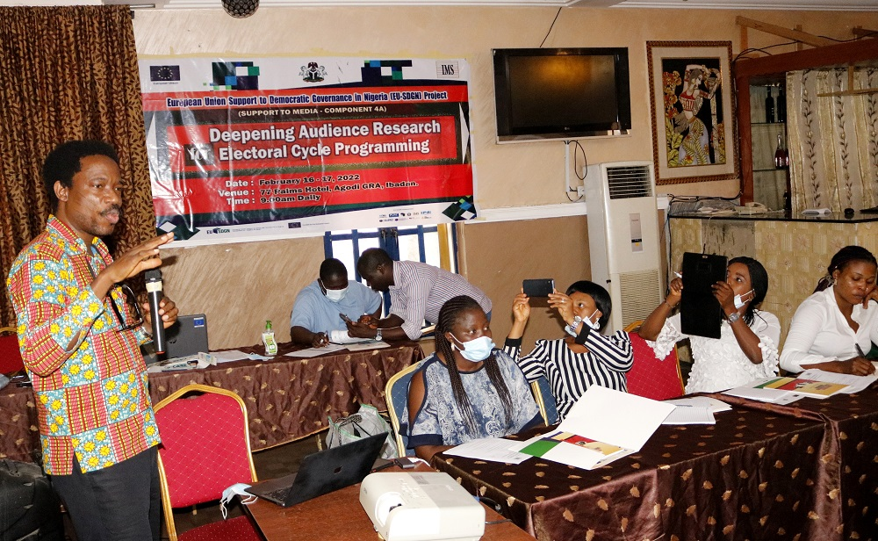
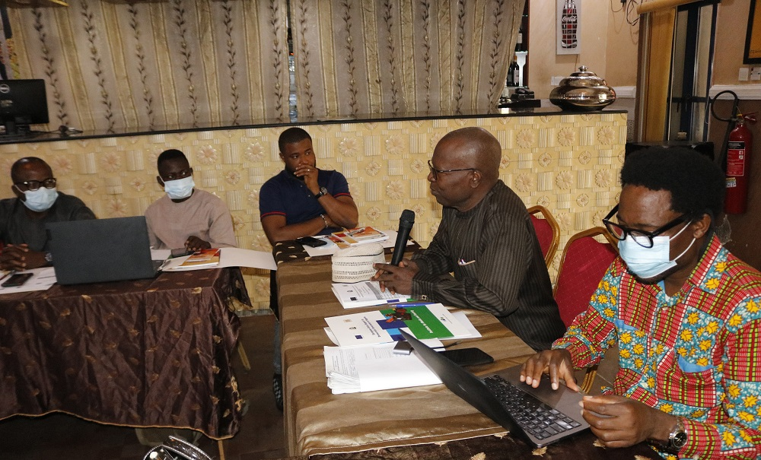
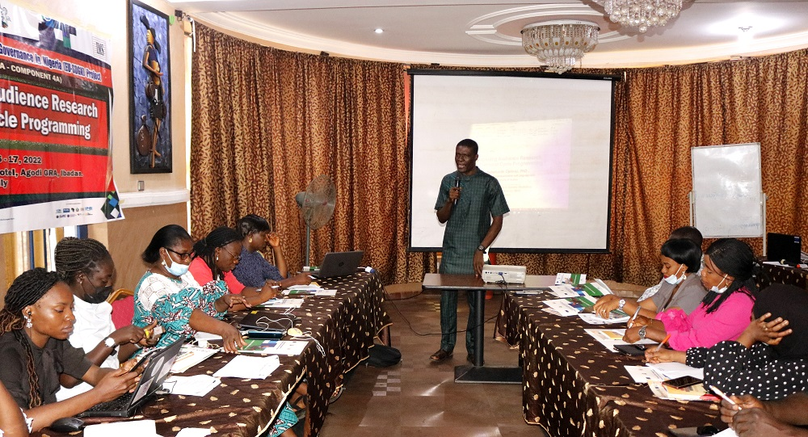
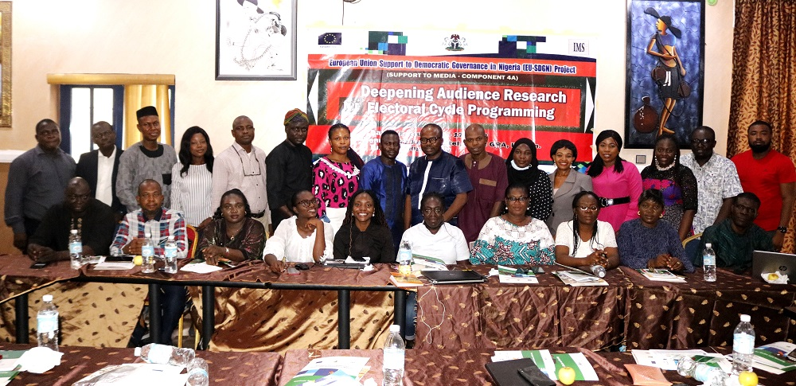

Photograph taken at the capacity building on Audience Research for Electoral Cycle Programming
held between February 16-17, 2022 in Ibadan.

